Hello Guys,

Just want to share with you one possible way how quickly install needed certificate on WS7.

This is needed for using new endpoint address for "AccountApplication" service: accountApplicationWebService.endpoint=https://preprod.ctal.ctc/WebICGateway/services/AccountAcquisitionPortal?wsdl

1) Go to "Security" section

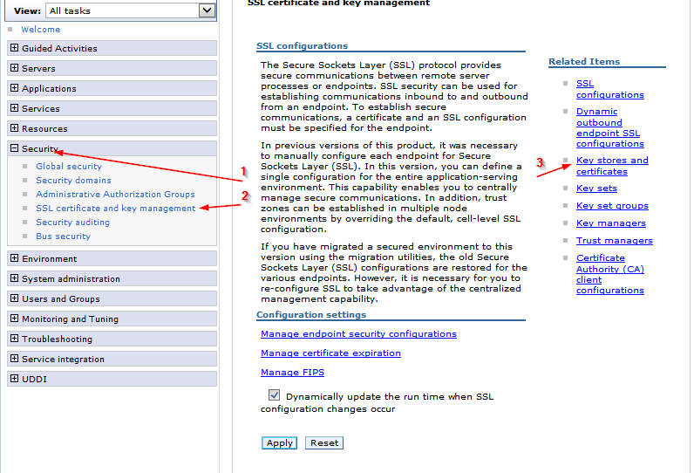

2) Select "trust store"

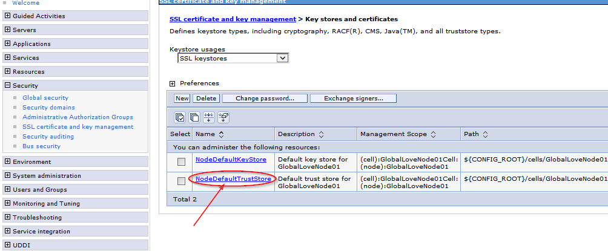

3) Select "signed certificates" property

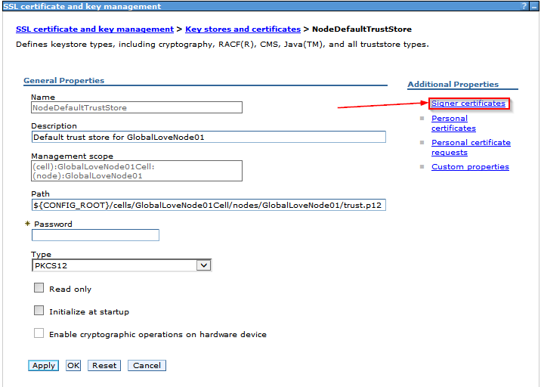

4) Click on "Retrieve from port" button

prepr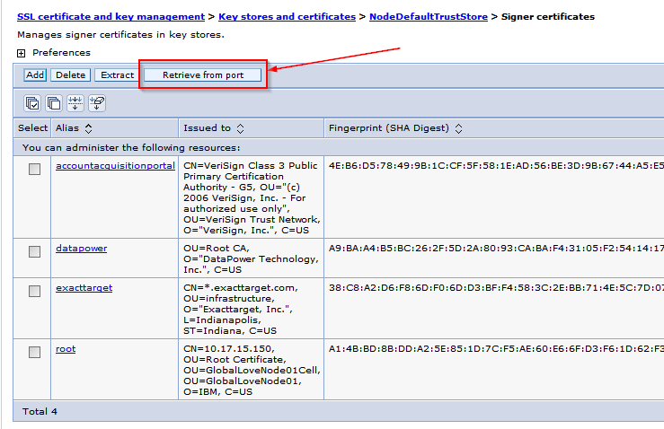

5) Populate needed fields

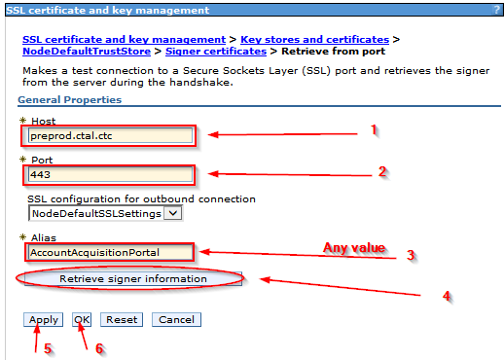

6) Go back and check result:

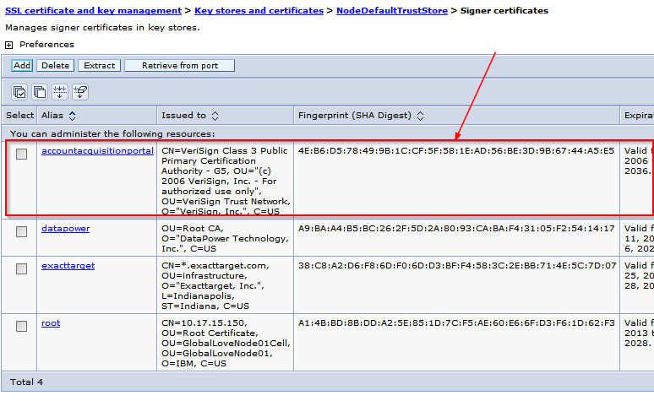

Information about certificate should be the same as we can see via web browser.

That's it.